AHRI Releases December 2017 U.S. Heating and Cooling Equipment Shipment Data

Warm Air Furnaces
U.S. shipments of gas warm air furnaces for December 2017 increased 2.6 percent, to 310,688 units, up from 302,668 units shipped in December 2016. Oil warm air furnace shipments decreased 14.2 percent, to 4,730 units in December 2017, down from 5,510 units shipped in December 2016.

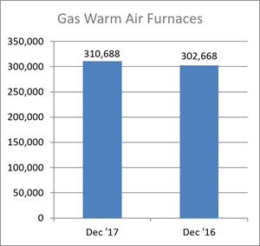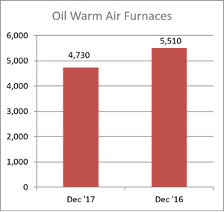

Year-to-date U.S. shipments of gas warm air furnaces increased 6.5 percent, to 3,133,768 units, compared with 2,942,545 units shipped during the same period in 2016. Year-to-date U.S. shipments of oil warm air furnaces decreased 1.3 percent, to 37,268 units, compared with 37,743 units shipped during the same period in 2016.

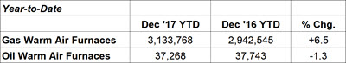

Central Air Conditioners and Air-Source Heat Pumps
U.S. shipments of central air conditioners and air-source heat pumps totaled 473,496 units in December 2017, up 6.3 percent from 445,355 units shipped in December 2016. U.S. shipments of air conditioners increased 4.5 percent, to 293,983 units, up from 281,407 units shipped in December 2016. U.S. shipments of air-source heat pumps increased 9.5 percent, to 179,513 units, up from 163,948 units shipped in December 2016.

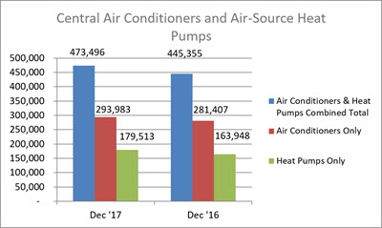

Year-to-date combined shipments of central air conditioners and air-source heat pumps increased 6.5 percent, to 7,805,529, up from 7,330,859 units shipped in December 2016. Year-to-date shipments of central air conditioners increased 5.8 percent, to 5,185,747 units, up from 4,900,992 units shipped during the same period in 2016. The year-to-date total for heat pump shipments increased 7.8 percent, to 2,619,782, up from 2,429,867 units shipped during the same period in 2016.

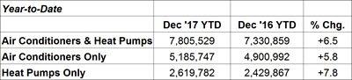

U.S. Manufacturers' Shipments of Central Air Conditioners and Air-Source Heat Pumps

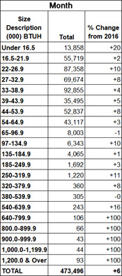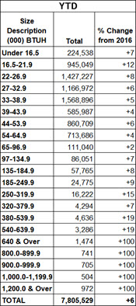

BTUHs of 64.9 and below are for residential units; 65.0 and above for commercial.

NOTE: A shipment is defined as when a unit transfers ownership; a consignment is not a transfer of ownership. Industry data is aggregated from the information supplied by AHRI member companies that participate in the statistics program and could be subject to revision. Published year-to-date data is inclusive of all revisions. No other AHRI data (e.g., by state or region) is available to the general public other than that published. AHRI does not conduct any market forecasting and is not qualified to discuss market trends. For previous monthly shipment releases and historical data, please see http://www.ahrinet.org/statistics.

###

